Discussion 1

#Project Initialization

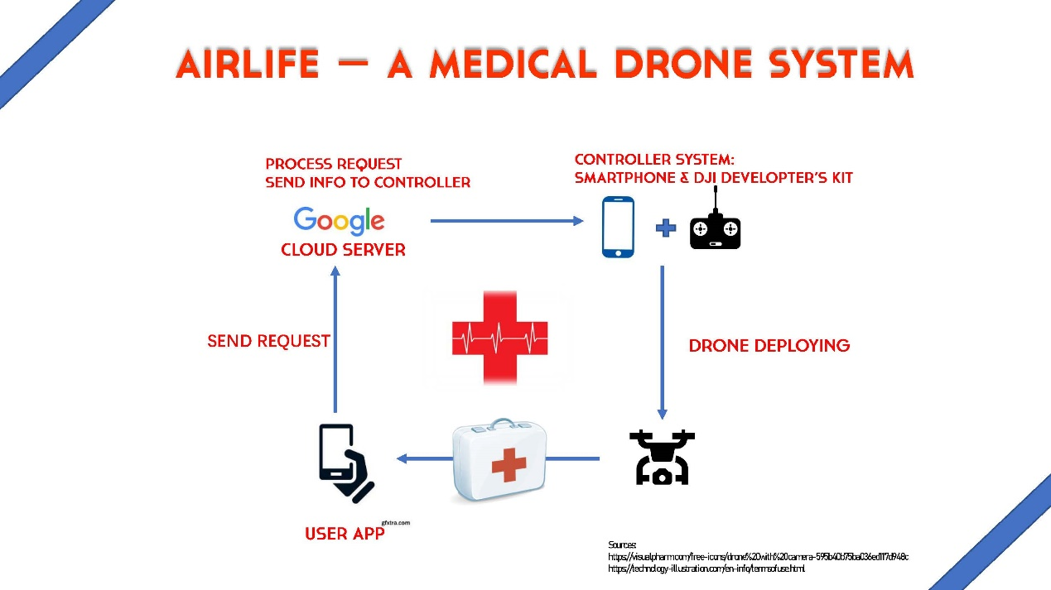

Project Description

The project can be divided in 4 parts:

1. Uerer App Development
2. Server Building
3. Drone Control and Communication between Drone and Server
4. Computer Vision Aid in User Identification

Member Responsbility:

1. Zhifang Zeng: Computer Vision Aid
2. Yuting Jiang: Drone Control and Communication
3. Shiyu Guo: User App Development
4. Weixi Wang; Server Building

Equipment:

1. DJI Spark
2. Google Cloud Server Renting

Discussion:

1. Some details of the equipment selection.
2. A specific double week plan.

Week\*2 Plan:

1. Equipment Purchasing
2. Sever Environment Building
3. User App Prototype